**Problem Statement**

Road accidents claim countless lives annually, often due to delayed emergency response. An automated, real-time accident detection system can mitigate this by promptly alerting authorities and emergency contacts, potentially saving lives. The proposed system leverages the ESP8266 microcontroller, paired with a vibration sensor (e.g., SW-420 or MPU6050) to detect impacts indicative of accidents. Integrated with a GPS module (Neo-6M), it captures precise location data. Upon detecting an accident, the system triggers a buzzer for local alerts and sends notifications with GPS coordinates to an IoT platform (e.g., Blynk or ThingSpeak) via Wi-Fi. This ensures rapid communication with emergency services or predefined contacts. Designed for scalability, the system can be integrated into vehicles or two-wheelers, offering a cost-effective, reliable solution to enhance road safety by reducing response times and improving the chances of timely medical intervention.

**Scope of the Solution**

The Accident Detection System uses an ESP8266 to detect road accidents via a vibration sensor (SW-420 or MPU6050) and sends real-time alerts through Wi-Fi. A GPS module (Neo-6M) provides accurate location data, transmitted to emergency services or contacts via an IoT platform like Blynk or ThingSpeak. The system triggers local alerts with a buzzer and LEDs for status indication. It supports remote monitoring and is scalable for integration into vehicles or two-wheelers. The solution ensures rapid response, cost-effectiveness, and reliability, enhancing road safety by enabling timely emergency intervention.

**Required Components**

**Components of Hardware:**

* **ESP8266 (NodeMCU)**: Microcontroller with Wi-Fi for connectivity.
* **Vibration Sensor (SW-420 or MPU6050)**: Detects impact or shock.
* **GPS Module (Neo-6M)**: Provides location data.
* **Buzzer**: Local audible alert.
* **LEDs**: Status indicators (e.g., power, alert triggered).
* **Power Supply**: 3.3V/5V battery or USB.

**Software & Tools:**

* **Arduino IDE**: For programming the ESP8266.
* **Fritzing/Tinkercad**: For circuit design and simulation.
* **GitHub**: For code hosting and documentation.
* **Blynk/ThingSpeak**: IoT platforms for remote monitoring

**Simulated Circuit**

**Circuit Design** :(**Fritzing)**

* **ESP8266 NodeMCU**: Central microcontroller.
* **SW-420 Vibration Sensor**: Connected to D2 (signal), 3.3V (VCC), GND.
* **Neo-6M GPS Module**: TX to D5, RX to D6, VCC to 3.3V, GND.
* **Buzzer**: Positive to D1, negative to GND.
* **LED**: Positive to D7 (with 220Ω resistor), negative to GND.
* **Power**: 3.3V from NodeMCU or external battery.

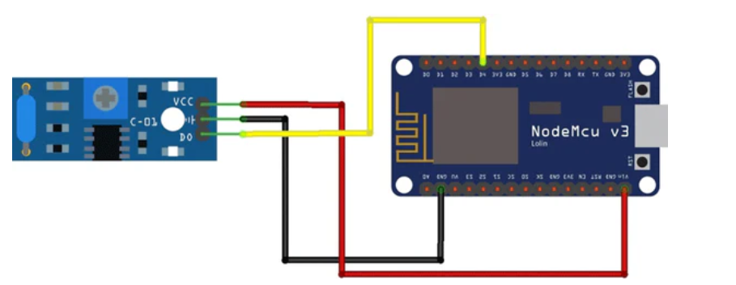

**Vibration Sensor**

**Demo Video**

**Demo video is available in GitHub in https://github.com/siri45704/Accident-Detection-System**

**Gerber File**

**PCB Design**

* **Tool**: Use EasyEDA (easyeda.com) or Fritzing for PCB design.
* **Components**:
  + ESP8266 NodeMCU footprint.
  + SW-420 sensor (3-pin: VCC, GND, signal).
  + Neo-6M GPS module (4-pin: VCC, GND, TX, RX).
  + Buzzer (2-pin).
  + LED with 220Ω resistor.
  + Voltage regulator (e.g., AMS1117-3.3 for 3.3V stability).
* **Connections**: Map pins as in the circuit (D2 for SW-420, D5/D6 for GPS, D1 for buzzer, D7 for LED).
* **Power**: Include 3.3V regulator and connectors for battery/USB.

**Code:**

#include <ESP8266WiFi.h>

#include <SoftwareSerial.h>

#include <TinyGPS++.h>

#include <BlynkSimpleEsp8266.h>

char auth[] = "Your_Blynk_Token"; // Replace with Blynk auth token

char ssid[] = "Your_WiFi_SSID";   // Replace with Wi-Fi SSID

char pass[] = "Your_WiFi_Password"; // Replace with Wi-Fi password

SoftwareSerial gpsSerial(D5, D6); // GPS TX to D5, RX to D6

TinyGPSPlus gps;

int vibSensor = D2; // Vibration sensor pin

int buzzer = D1;    // Buzzer pin

int led = D7;       // LED pin

void setup() {

  Serial.begin(9600);

  gpsSerial.begin(9600);

  pinMode(vibSensor, INPUT);

  pinMode(buzzer, OUTPUT);

  pinMode(led, OUTPUT);

  Blynk.begin(auth, ssid, pass);

}

void loop() {

  Blynk.run();

  while (gpsSerial.available()) {

    gps.encode(gpsSerial.read());

  }

  int shock = digitalRead(vibSensor);

  if (shock == HIGH) {

    digitalWrite(buzzer, HIGH);

    digitalWrite(led, HIGH);

    if (gps.location.isValid()) {

      String msg = "Accident Detected! Location: ";

      msg += "Lat: " + String(gps.location.lat(), 6);

      msg += ", Lon: " + String(gps.location.lng(), 6);

      Blynk.logEvent("accident_alert", msg);

      Serial.println(msg);

    } else {

      Blynk.logEvent("accident_alert", "Accident Detected! GPS data unavailable.");

      Serial.println("GPS data unavailable.");

    }

    delay(10000); // Alert for 10 seconds

    digitalWrite(buzzer, LOW);

    digitalWrite(led, LOW);

  }

}